## **Hands-On Activity: Combine multiple pieces of data**

1.

Question 1



## Activity overview



In previous activities, you gained experience using spreadsheet functions for manipulating and cleaning data. In this activity, you’ll use the CONCAT and CONCATENATE functions to help you quickly and efficiently combine multiple pieces of raw data into new data.

By the time you complete this activity, you will be able to use these functions to combine data. This will enable you to simplify and condense data, which is important for processing and cleaning data in your career as a data analyst.



### What you will need

To get started, first access the CONCAT function exercise spreadsheet.

Click the link to the spreadsheet to create a copy. If you don’t have a Google account, you may download the spreadsheet directly from the attachments below.

Link to the spreadsheet: [CONCAT Function Exercise Spreadsheet](https://docs.google.com/spreadsheets/d/1Na9M4xb-3CA746BHECX75n3B9V04pxLo0xNs9i8jMNo/template/preview)

OR

Download CONCAT function exercise spreadsheet:

[Dataset for Project_ CONCAT function.xlsx](https://d3c33hcgiwev3.cloudfront.net/s7PLxn9URlSzy8Z_VDZUqQ_90e1fe6271aa400cb7a05c5ba5c40a56_Dataset-for-Project_-CONCAT-function.xlsx?Expires=1623283200&Signature=Ihu28OnjH2f5LBolqRcwxT5wfgpsSGIA0tBjQX47LbZaO3ZxKMdQi8z2G0jAfOL8GXzh2ODaxh-sVGvAlDyjVmEhNuo3t-kxiNmR~0nUVpVURzXlkqyBUz5btf6u33lIxCiRnQAxTR90ya0A02i4h6q4bxI64LV4oTL6AFjBSZQ_&Key-Pair-Id=APKAJLTNE6QMUY6HBC5A)

[](https://d3c33hcgiwev3.cloudfront.net/s7PLxn9URlSzy8Z_VDZUqQ_90e1fe6271aa400cb7a05c5ba5c40a56_Dataset-for-Project_-CONCAT-function.xlsx?Expires=1623283200&Signature=Ihu28OnjH2f5LBolqRcwxT5wfgpsSGIA0tBjQX47LbZaO3ZxKMdQi8z2G0jAfOL8GXzh2ODaxh-sVGvAlDyjVmEhNuo3t-kxiNmR~0nUVpVURzXlkqyBUz5btf6u33lIxCiRnQAxTR90ya0A02i4h6q4bxI64LV4oTL6AFjBSZQ_&Key-Pair-Id=APKAJLTNE6QMUY6HBC5A)

## Using the CONCAT and CONCATENATE functions



Occasionally, you will encounter a dataset with data values in separate cells that you want to combine as a single value in a single cell. This is common when dealing with names and dates. The dataset may have separate columns for first names and last names, but you may want a column with the full names.

City/state and month/year combinations are also often desirable to have together, as they are likely to be recorded together.

The CONCAT function in spreadsheets can combine these kinds of data.

## Combining data from two cells



First, using the spreadsheet you downloaded, you’ll combine the two sets of names in columns First Name and Last Name in a new column called Full Name.

To do this, follow these steps:

1. Click on cell F2. This is where you start the data for the new column. After you click on the cell, type =CONCAT(A2,B2) into the function bar and hit Enter (Windows) or Return (Mac).

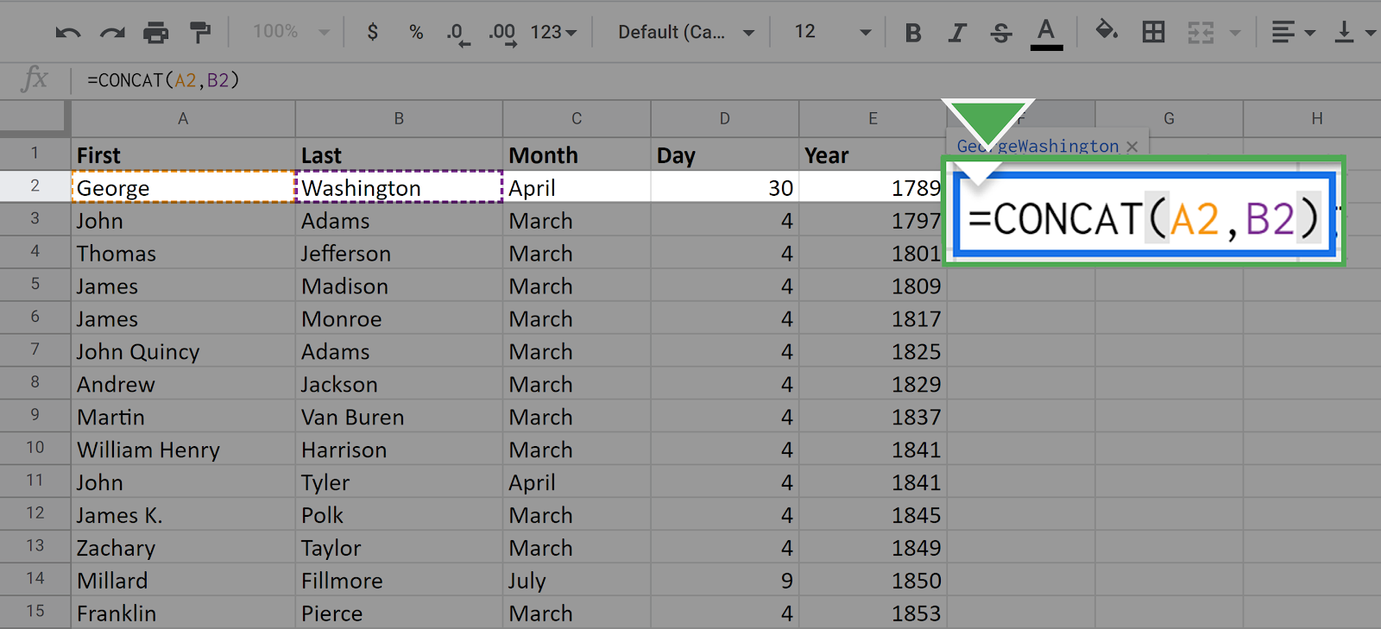

Once you press enter, the following data should appear in the cell:

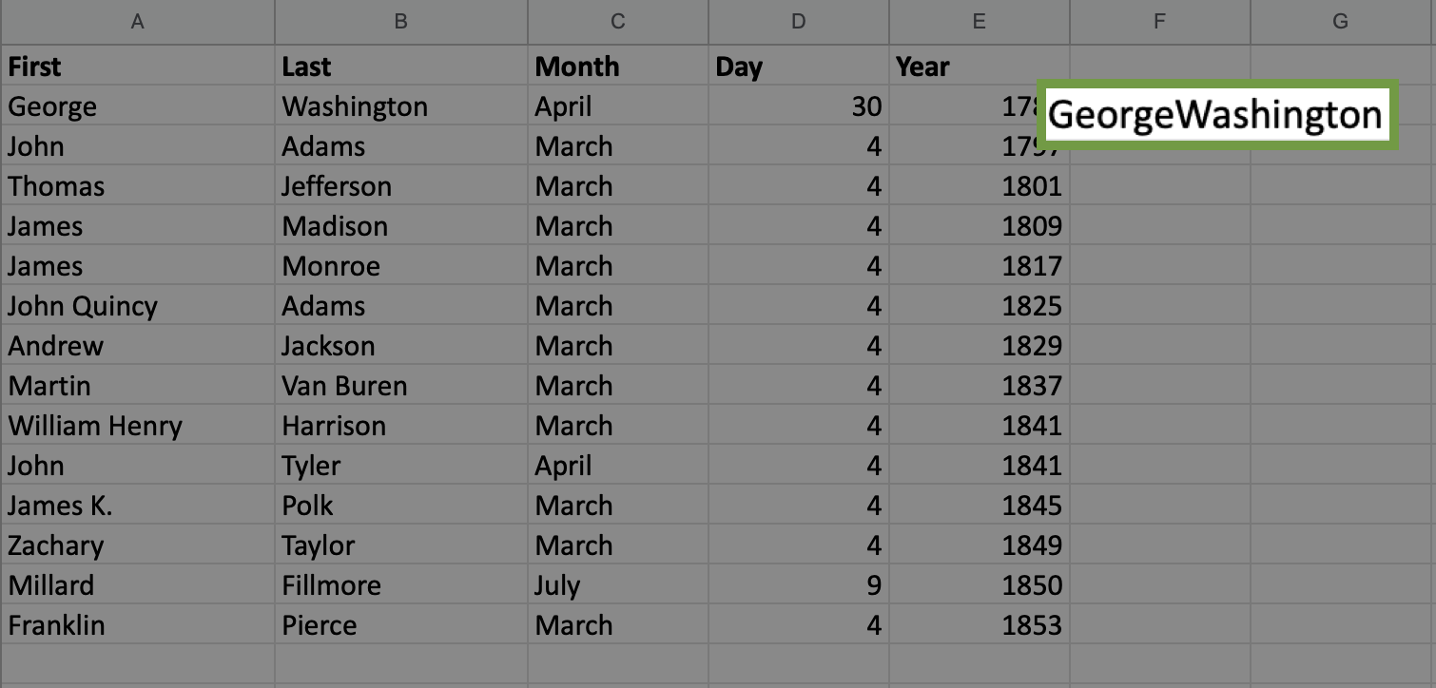

You have merged or, technically, concatenated the two data values from cells A2 and B2. Because you listed A2 first in the CONCAT function argument, it comes first in the final result.

Notice that the two names were combined without a space between them.

If you want to put the space in between, you need to use the full CONCATENATE function, which allows you to combine multiple strings.

2. Click again on the cell F2. In the function call, place a space in quotes between A2 and B2 separated by commas.

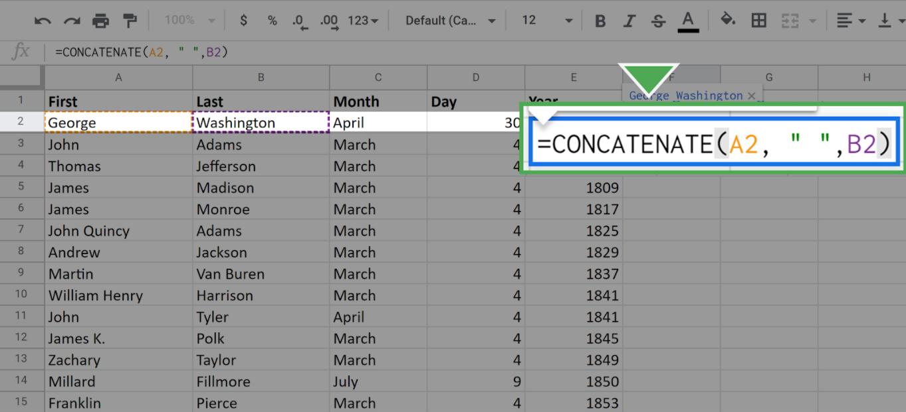

Once you press enter or return, your screen should appear like this:

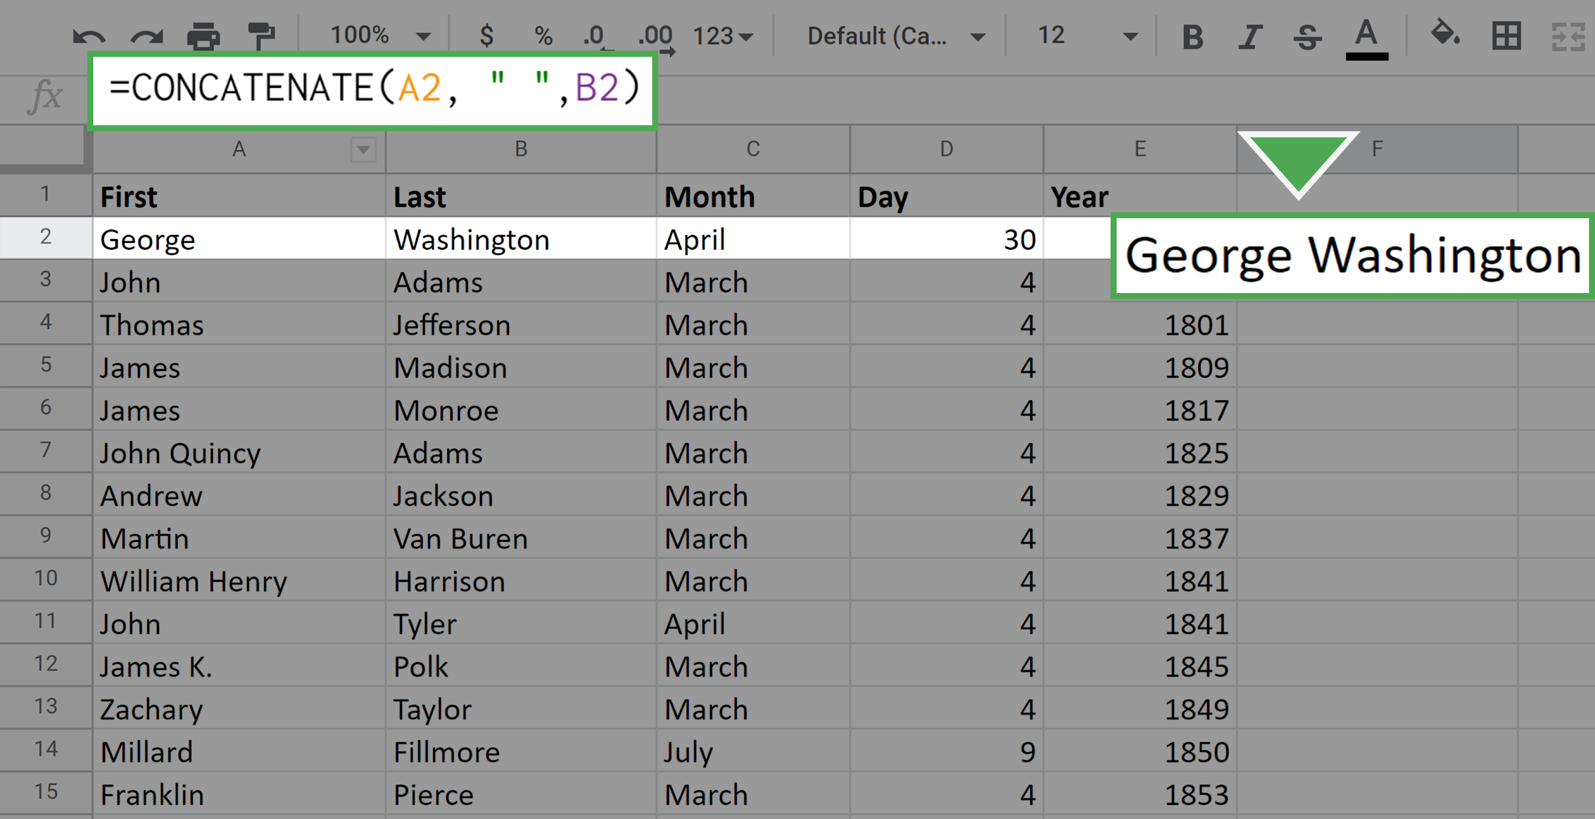

Now there is a space between the first name and the last name.

Next, repeat this process for all the remaining cells in Column F. Of course, you don't want to do this manually for each cell. (Especially if the dataset were larger, it would be laborious to do this cell-by-cell.) Luckily, you can fill out the data in the column by using your mouse.

1. Click on the cell F2. Locate the small square in the lower-right corner of the highlighted boundary of the cell.

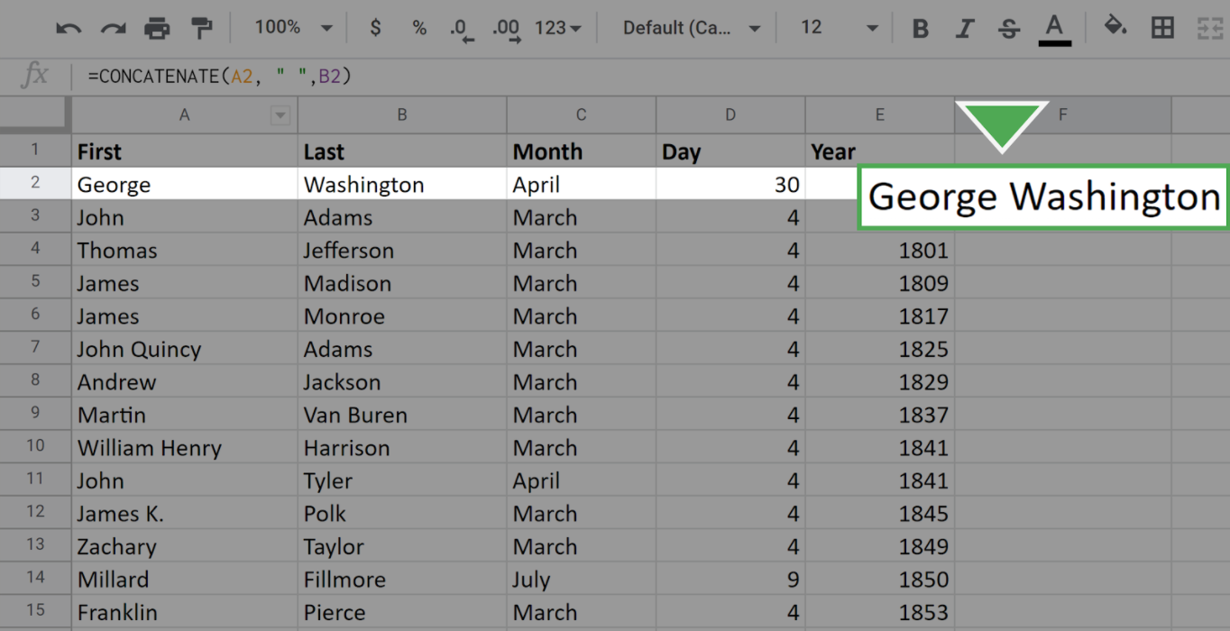

2. Click on this square, drag your mouse to the bottom of the column, and release. All the cells in the column should populate with the full name of the appropriate president.

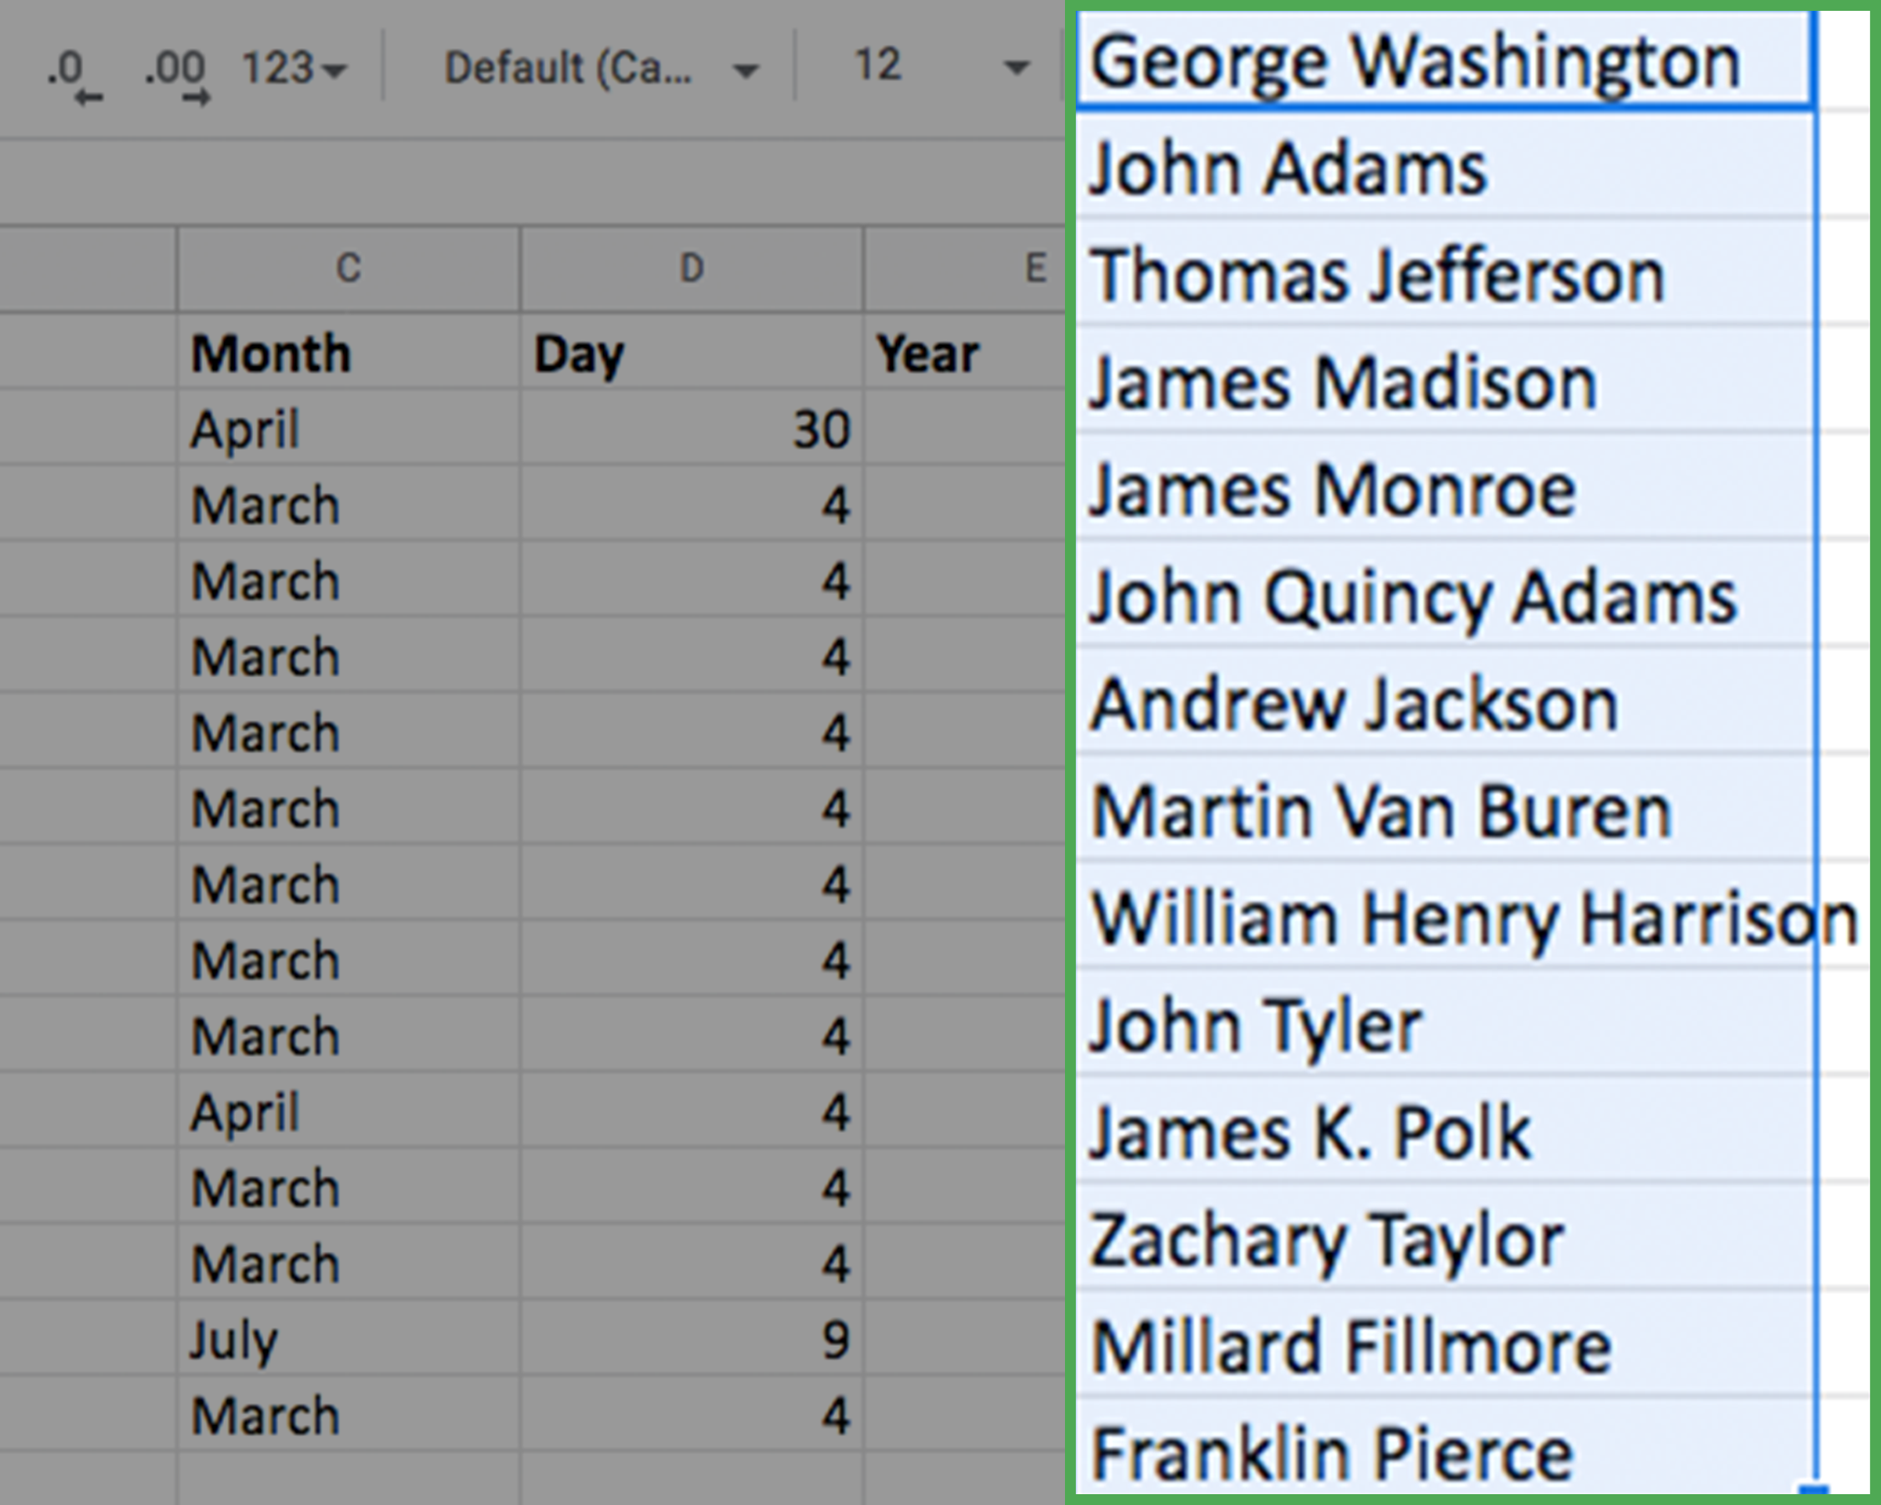

* Note: While it does not happen in this dataset, you may have extra spaces in your result after you CONCAT. If you notice you have extra spaces, you can use the TRIM function to remove them.

## Combining data from three cells



The procedure for combining three pieces of data from different cells is almost identical to what you just did. The only difference is that you include a third cell in the full CONCATENATE argument.

Now, combine the month, day, and year into a single data value: Date. This will occupy column G.

1. Click on the cell where you would like the new data to start. Here, this is cell G2.

2. Enter the CONCAT command as =CONCATENATE(C2," ",D2,", ",E2)

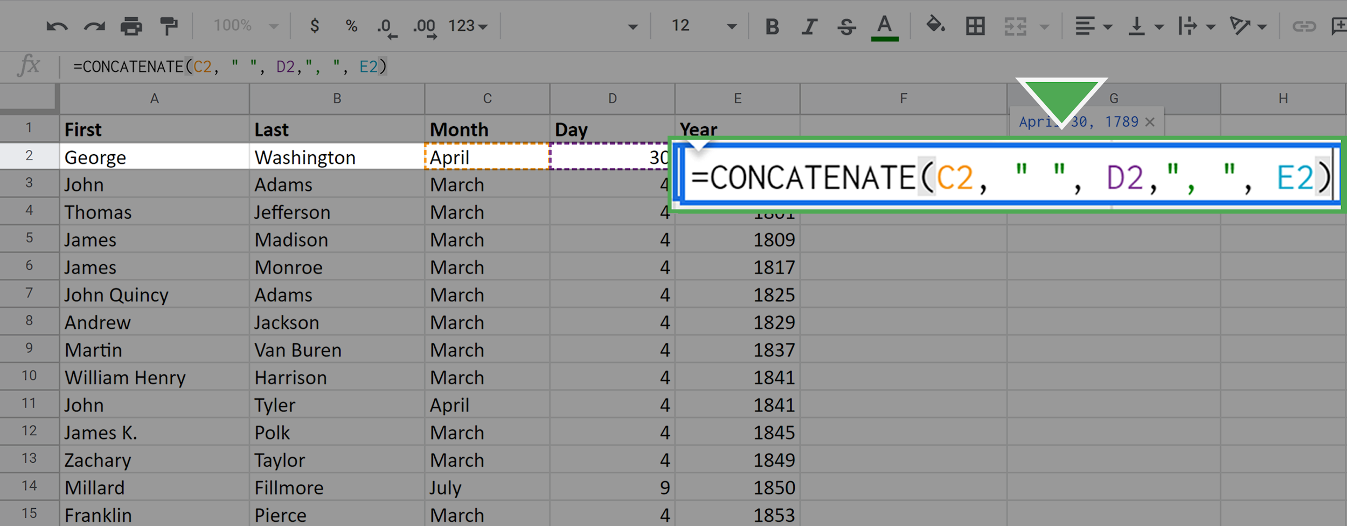

Pay particular attention to the extra strings you added between the month and the day, and between the day and the year. This is how you get the spaces and comma in your final result.

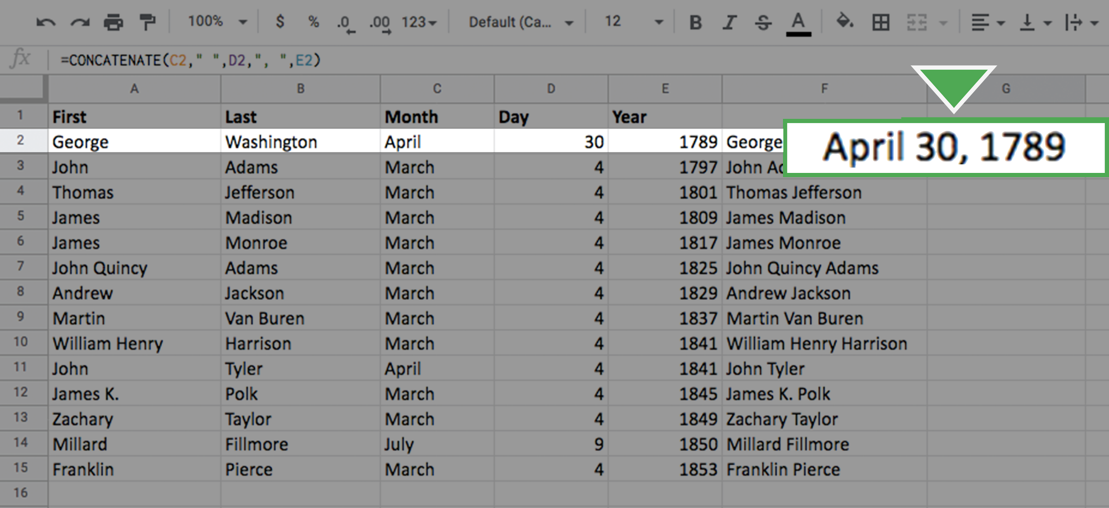

3. Fill out the rest of the column using the same click-and-drag technique as before. Your screen should appear like this:

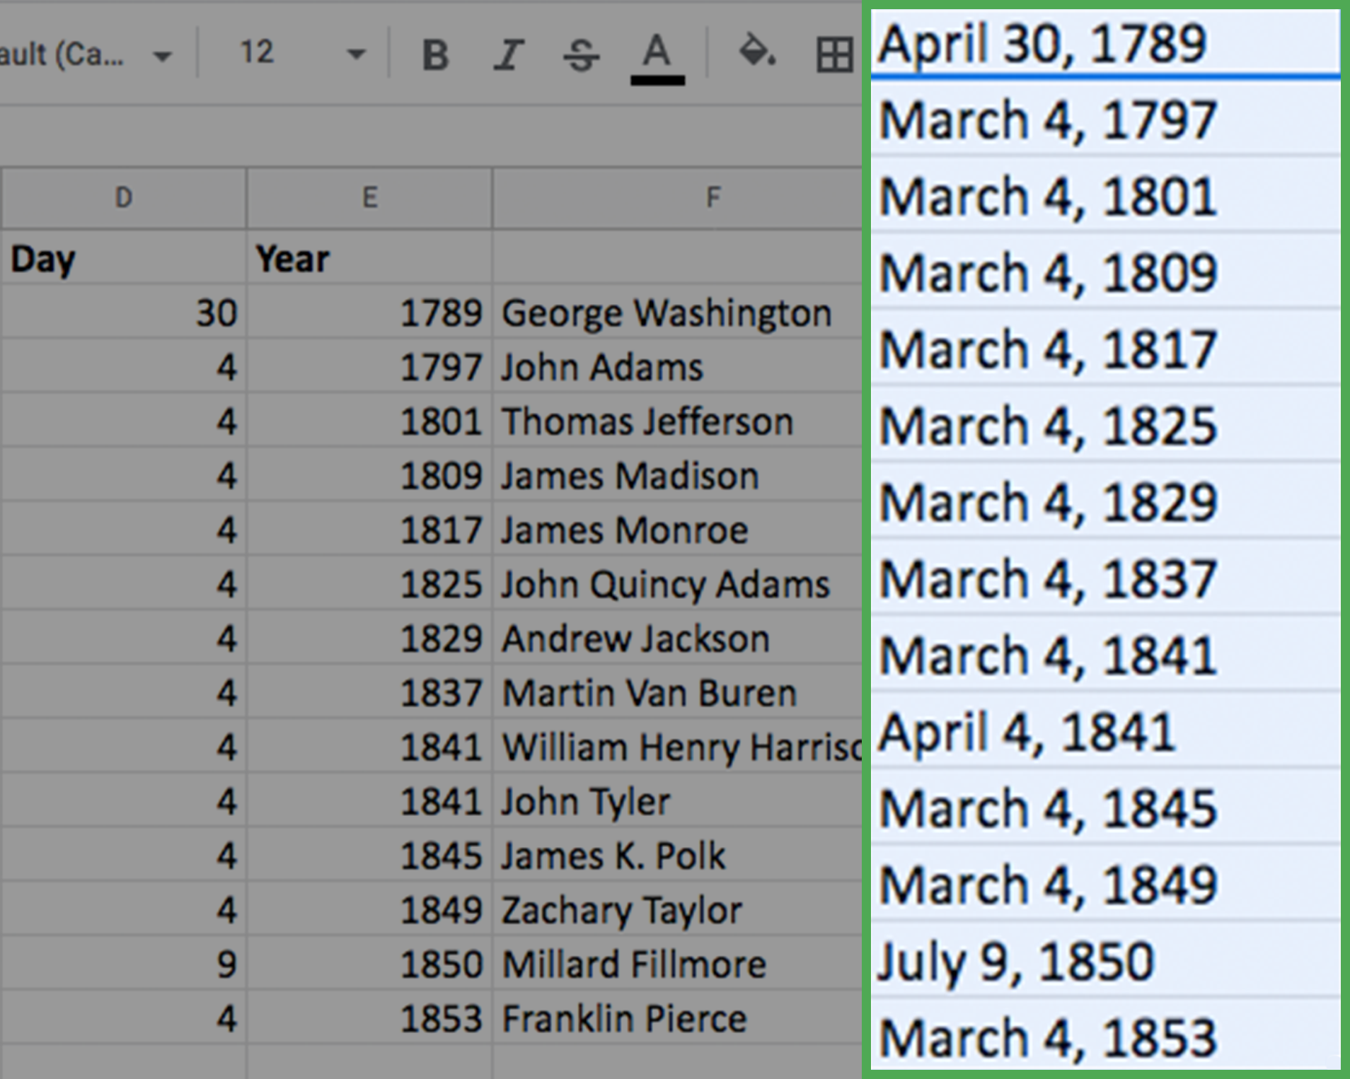

Congratulations! You’ve combined data in spreadsheets using the CONCAT and CONCATENATE functions.

## Confirmation and reflection



In an empty cell in the CONCAT function exercise spreadsheet, type the function =CONCATENATE(A7, " ", B7). What does this function return?

**1 / 1 point**

JohnQuincyAdams

John Quincy Adams

John QuincyAdams

#N/A

**Correct**

The function =CONCATENATE(A7, " ", B7) would return "John Quincy Adams." The correct function to use here would be CONCATENATE, which you can use to combine strings. Using CONCAT with these arguments would resolve this correctly in Microsoft Excel, but return an error in Google Sheets. Going forward, you can use this distinction to write proper spreadsheet functions.

2.

Question 2

In this activity, you used spreadsheet functions to combine data. In the text box below, write 2-3 sentences (40-60 words) in response to each of the following questions:

* What are some other kinds of data you could combine using CONCAT or CONCATENATE?
* What happens if a data analyst tries to work with dates or names that haven’t been combined with CONCAT or CONCATENATE?

**1 / 1 point**

**Correct**

Congratulations on completing this hands-on activity! A good response would include how combining data with CONCAT and CONCATENATE helps you simplify and clean data by combining string data from multiple cells into a single cell.

In order to properly and efficiently analyze data, the data has to be clean and understandable. Data analysts use functions like CONCAT to make data easier to work with, which may require combining multiple cells. Coming up, you will learn more spreadsheet functions that will help you analyze data in spreadsheets.